实验报告
课程 数据结构与算法 实验名称 图的BFST和DFST的实现 第 1 页
专业_____软件工程_____ 班级___ 一班____ 学号_121052022022_ 姓名 张家豪
实验日期：2023年05月25日 报告退发 (订正 、 重做)
一、实验目的
1）能够实现图的遍历：深度优先搜索、广度优先搜索
2）能够执行图的遍历算法给出结果
二、实验内容
1）实现图的深度优先遍历算法
2）实现图的广度优先遍历算法
三、实验环境
Visual Studio 2022
Windows 11 操作系统
四、实验步骤
头文件AMGraph.h
#pragma once

#include <stdio.h>
#include <stdlib.h>
#include <string.h>
#include <assert.h>
#include <stdbool.h>

#define VertexMax 10 //最大顶点数
#define MaxSize 10 //队列最大元素个数
#define MaxInt 32767 //最大整数，表示∞

typedef char VertexType; //顶点数据类型
typedef int DataType; //队列数据类型

typedef enum
{
DG, UDG, DN, UDN
}GraphKind;

typedef struct MGraph
{
VertexType Vertex[VertexMax]; //存放顶点元素的数组
int AdjMatrix[VertexMax][VertexMax]; //邻接矩阵
int VexNum, ArcNum;
int kind; //图的类型
}MGraph;

typedef struct CQueue
{
DataType* base;
int front;
int rear;
}CQueue;

int LocateVex(MGraph* G, VertexType v);//查找顶点在一维数组的下标，并返回下标

void CreateDG(MGraph* G);//创建有向图(Directed Graph)
void CreateUDG(MGraph* G);//创建无向图(Undirected Graph)
void CreateDN(MGraph* G);//创建有向网(Directed Network)
void CreateUDN(MGraph* G);//创建无向网(Undirected Nexwork)

void GraphChoice(MGraph* G);//选择图的类型

void PrintMatrix(MGraph G);//打印邻接矩阵

void CreateCQueue(CQueue* Q);//创建循环队列
void EnQueue(CQueue* Q, DataType data);//入队
void DeQueue(CQueue* Q, DataType* data);//出队
bool QueueEmpty(CQueue* Q);//判断队列是否为空，若空则返回true，否则返回false
bool QueueFull(CQueue* Q);//判断队列是否为满，若满则返回true，否则返回false

void BFS(MGraph* G, int i);//Breadth_First Search广度优先搜索(无向图UDG)
void BFSTraverse(MGraph* G);//Breadth_First Search Traverse广度优先遍历(无向图UDG)

void DFS(MGraph* G, int i);//Depth_First Search深度优先搜索(无向图UDG)
void DFSTraverse(MGraph* G);//Depth_First Search Traverse深度优先搜索(无向图UDG)
源文件AMGraph.c
#pragma warning(disable:6031)

#define _CRT_SECURE_NO_WARNINGS

#include "AMGraph.h"

int visited[VertexMax]; //定义全局变量标志数组，若被访问过则置为1，否则为0

int LocateVex(MGraph* G, VertexType v)
{
for (int i = 0; i < G->VexNum; i++)
{
if (v == G->Vertex[i])
{
return i;
}
}

printf("No Such Vertex!");
return -1;
}

void CreateDG(MGraph* G)
{
printf("输入顶点的个数和边数(用逗号隔开):");
scanf("%d,%d", &G->VexNum, &G->ArcNum);
printf("\n");

printf("输入顶点元素(无需空格隔开):");
scanf("%s", G->Vertex);
printf("\n");

//初始化邻接矩阵，矩阵元素全部置零
for (int i = 0; i < G->VexNum; i++)
{
for (int j = 0; j < G->VexNum; j++)
{
G->AdjMatrix[i][j] = 0;
}
}

//构建邻接矩阵
VertexType v1, v2;
printf("请输入边的信息:\n");
for (int i = 0; i < G->ArcNum; i++)
{
printf("Arc%02d\t", i + 1);
scanf(" %c%c", &v1, &v2);
int n = LocateVex(G, v1); //v1的下标
int m = LocateVex(G, v2); //v2的下标

if (n == -1 || m == -1)
{
printf("This Vertex Does Not Exist!\n");
return;
}
G->AdjMatrix[n][m] = 1;
}
G->kind = 1;
}

void CreateUDG(MGraph* G)
{
printf("输入顶点的个数和边数(用逗号隔开):");
scanf("%d,%d", &G->VexNum, &G->ArcNum);
printf("\n");

printf("输入顶点元素(无需空格隔开):");
scanf("%s", G->Vertex);
printf("\n");

for (int i = 0; i < G->VexNum; i++)
{
for (int j = 0; j < G->VexNum; j++)
{
G->AdjMatrix[i][j] = 0;
}
}

VertexType v1, v2;
printf("请输入边的信息:\n");
for (int i = 0; i < G->ArcNum; i++)
{
printf("Arc%02d\t", i + 1);
scanf(" %c%c", &v1, &v2);
int n = LocateVex(G, v1);
int m = LocateVex(G, v2);

if (n == -1 || m == -1)
{
printf("This Vertex Does Not Exist!\n");
return;
}
G->AdjMatrix[n][m] = 1;
G->AdjMatrix[m][n] = 1;
}
G->kind = 2;
}

void CreateDN(MGraph* G)
{
printf("输入顶点的个数和边数(用逗号隔开):");
scanf("%d,%d", &G->VexNum, &G->ArcNum);
printf("\n");

printf("输入顶点元素(无需空格隔开):");
scanf("%s", G->Vertex);
printf("\n");

for (int i = 0; i < G->VexNum; i++)
{
for (int j = 0; j < G->VexNum; j++)
{
G->AdjMatrix[i][j] = MaxInt;
}
}

VertexType v1, v2;
int w; //边的权值
printf("请输入边的信息:\n");
for (int i = 0; i < G->ArcNum; i++)
{
printf("Arc%02d\t", i + 1);
scanf(" %c%c,%d", &v1, &v2, &w);
int n = LocateVex(G, v1);
int m = LocateVex(G, v2);

if (n == -1 || m == -1)
{
printf("This Vertex Does Not Exist!\n");
return;
}
G->AdjMatrix[n][m] = w;
}
G->kind = 3;
}

void CreateUDN(MGraph* G)
{
printf("输入顶点的个数和边数(用逗号隔开):");
scanf("%d,%d", &G->VexNum, &G->ArcNum);
printf("\n");

printf("输入顶点元素(无需空格隔开):");
scanf("%s", G->Vertex);
printf("\n");

for (int i = 0; i < G->VexNum; i++)
{
for (int j = 0; j < G->VexNum; j++)
{
G->AdjMatrix[i][j] = MaxInt;
}
}

VertexType v1, v2;
int w;
printf("请输入边的信息:\n");
for (int i = 0; i < G->ArcNum; i++)
{
printf("Arc%02d\t", i + 1);
scanf(" %c%c,%d", &v1, &v2, &w);
int n = LocateVex(G, v1);
int m = LocateVex(G, v2);

if (n == -1 || m == -1)
{
printf("This Vertex Does Not Exist!\n");
return;
}
G->AdjMatrix[n][m] = w;
G->AdjMatrix[m][n] = w;
}
G->kind = 4;
}

void GraphChoice(MGraph* G)
{
int target;
printf(" 请选择图的类型: 1.有向图DG 2.无向图UDG 3.有向网DN 4.无向网UDN\n\n");
scanf("%d", &target);
printf("\n");

switch (target)
{
case 1:
printf("选择了有向图DG\n\n");
CreateDG(G);
break;
case 2:
printf("选择了无向图UDG\n\n");
CreateUDG(G);
break;
case 3:
printf("选择了有向网DN\n\n");
CreateDN(G);
break;
case 4:
printf("选择了无向网UDN\n\n");
CreateUDN(G);
break;
default:
printf("Error Choice!");
exit(-1);
break;
}
}

void PrintMatrix(MGraph G)
{
printf("\n-------------------------------------------------------");
printf("\n 邻接矩阵: \n\n");

if (G.kind == 1 || G.kind == 2)
{
printf("\t ");
for (int i = 0; i < G.VexNum; i++)
{
printf(" %c", G.Vertex[i]);
}
printf("\n");

for (int i = 0; i < G.VexNum; i++)
{
printf("\t%c", G.Vertex[i]);

for (int j = 0; j < G.VexNum; j++)
{
printf(" %d", G.AdjMatrix[i][j]);
}
printf("\n");
}
}

else if (G.kind == 3 || G.kind == 4)
{
printf("\t ");
for (int i = 0; i < G.VexNum; i++)
{
printf(" %c", G.Vertex[i]);
}
printf("\n");

for (int i = 0; i < G.VexNum; i++)
{
printf("\t%c", G.Vertex[i]);

for (int j = 0; j < G.VexNum; j++)
{
if (G.AdjMatrix[i][j] == MaxInt)
{
printf(" ∞");
}
else
{
printf(" %d", G.AdjMatrix[i][j]);
}
}
printf("\n");
}
printf("\n-------------------------------------------------------");
}
}

void CreateCQueue(CQueue* Q)
{
Q->base = (DataType*)malloc(sizeof(DataType) * MaxSize);
//assert(Q->base);
if (!Q->base)
{
printf("malloc fail");
exit(-1);
}
Q->front = Q->rear = 0;
return;
}

void EnQueue(CQueue* Q, DataType data)
{
//assert(Q);
if (QueueFull(Q))
{
printf("Queue is Ful\nl");
exit(-1);
}
Q->base[Q->rear] = data;
Q->rear = (Q->rear + 1) % MaxSize;
}

void DeQueue(CQueue* Q, DataType* data)
{
//assert(Q);
if (QueueEmpty(Q))
{
printf("Queue is Empty\n");
}
*data = Q->base[Q->front];
Q->front = (Q->front + 1) % MaxSize;
}

bool QueueEmpty(CQueue *Q)
{
assert(Q);
return Q->front == Q->rear;
}

bool QueueFull(CQueue *Q)
{
assert(Q);
return (Q->rear + 1) % MaxSize == Q->front;
}

void BFS(MGraph* G, int i)
{
assert(&G);
CQueue Q;
CreateCQueue(&Q);
assert(&Q);
//设置访问的起始点
printf("%c", G->Vertex[i]);
visited[i] = 1;
EnQueue(&Q, i);
//由起始点开始，对后续结点进行操作
while (!QueueEmpty(&Q))
{
DeQueue(&Q, &i);
for (int j = 0; j < G->VexNum; j++)
{
if (G->AdjMatrix[i][j] == 1 && visited[j] == 0)
{
printf("%c", G->Vertex[j]);
visited[j] = 1;
EnQueue(&Q, j);
}
}
}
}

void BFSTraverse(MGraph* G)
{
printf("\n-------------------------------------------------------");
printf("\n广度优先遍历:");
assert(&G);
for (int i = 0; i < G->VexNum; i++)
{
visited[i] = 0; //初始化数组全为0
}
for (int i = 0; i < G->VexNum; i++)
{
if (visited[i] == 0)
{
BFS(G, i);
}
}
printf("\n");
}

void DFS(MGraph* G, int i)
{
assert(&G);
//设置访问的起始点
printf("%c", G->Vertex[i]);
visited[i] = 1;
//由起始点开始，对后续结点操作
//依次搜索vi的邻接点
for (int j = 0; j < G->VexNum; j++)
{
if (G->AdjMatrix[i][j] == 1 && visited[j] == 0)
{
DFS(G, j);
}
}
}

void DFSTraverse(MGraph* G)
{
printf("\n-------------------------------------------------------");
printf("\n深度优先遍历:");
assert(&G);
for (int i = 0; i < G->VexNum; i++)
{
visited[i] = 0; //初始化访问标志数组
}
for (int i = 0; i < G->VexNum; i++)
{
if (visited[i] == 0)
{
DFS(G, i);
}
}
printf("\n");
}
测试文件test.c
#include "AMGraph.h"

int main()
{
MGraph G;
GraphChoice(&G);
PrintMatrix(G);

if (G.kind == 2)
{
BFSTraverse(&G);
DFSTraverse(&G);
}

return 0;
}
五、实验结果与讨论）
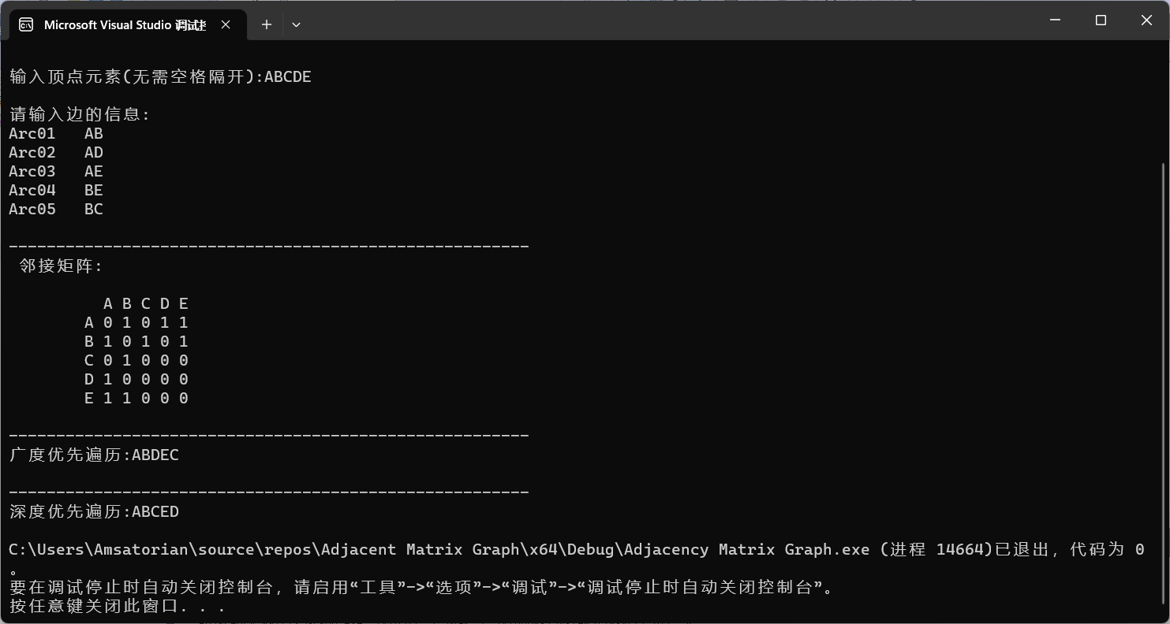
六、总结
通过实践动手操作，实现了邻接矩阵表示的无向图的深度优先遍历和广度优先遍历，收获颇多。

